Diagramming Sentences
Sentence diagramming is the process of taking a sentence apart, word by word, and placing each word on a pictorial relationship diagram which helps to show how the words are related to one another.
A simple sentence can be diagrammed very simply.
Wonderview rules!
Wonderview is the subject; rules is the verb. On a diagram you would simply underline both words with a complete underline, then draw a vertical line between the words to separate the subject from the predicate. The vertical line should cut through the base underline and extend just slightly below it.
Now, if we add a direct object to that sentence, answering "what" Wonderview rules:
Wonderview rules schools!
We simply add another vertical line between the direct object and the verb. This line, however, does not cut through the base underline.
If rather than a direct object we had instead used a sentence with a predicate noun which renames the subject, then instead of a vertical line between the verb and predicate noun we would use a line slanted backwards pointing back toward the subject.
Modifiers such as adverbs and adjectives are placed on slanted lines underneath the words they modify, so that the relationship can be seen easily.
For instance, in the sentence
The big dog quickly drank the cool water.
"The" and "big" modify DOG as adjectives,"quickly" is an adverb modifying the verb DRANK.
"the" and "cool" are adjectives modifying WATER.
On a diagram, this sentence would look like this:
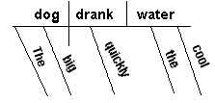
Now, if we were to add adverbs modifying other adverbs or adjectives such as in this sentence
The bright red balloon popped very suddenly.
"Bright" modifies the adjective "red", and "very" modifies the adverb "suddenly."
Diagrammed, the sentence would look like:
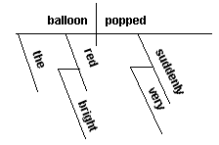
Adjectives and adverbs are always diagrammed on diagonal lines under the words they modify no matter what type of other line may be used.
Prepositional phrases are diagrammed on a "lazy L" underneath the word they are describing. As you know, prepositional phrases often act as adjective or adverb phrases so they would be placed under the appropriate noun or verb much like normal modifiers. Consider the following sentence:
The big dog in the pen was attacked by a large brown bear.
"in the pen" is a prepositional phrase acting as an adjective telling which dog; "by a large bear" is a prepositional phrase acting as an adverb telling how the dog was attacked. Both phrases have internal modifiers as well - "the, a, large, brown"
On a diagram, the sentence would look like this:
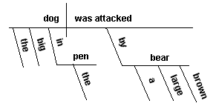
Indirect objects are much like prepositional phrases that are missing the preposition "to" or "for", so therefore they are diagrammed similarly to prepositional phrases, and are always placed under the verb. Consider the following sentence:
I gave my mother my keys.
"mother" is the INDIRECT object, "keys" is the DIRECT object.
Diagrammed, the sentence would look like this:
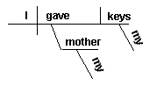
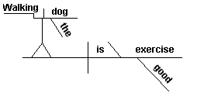
Compound items, whether they are subjects, verbs, modifiers, etc are joined together in the diagram in the position they would normally occupy if they were singular, but if conjunctions are used place a dashed line between the compound elements and place the conjunction on the dashed line. Consider the following sentence:
Bill and John drove the red and white car.
Diagrammed, the sentence would look like:
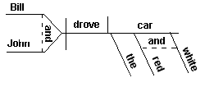
Another example:
Jane and Mary happily bought and quickly gave mom and dad their gifts and cards.
This very compound sentence contains compound subjects, compound verbs, compound indirect objects, and compound direct objects.
Diagrammed, this very complicated structure looks like this:
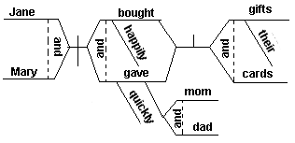
Gerunds are "ing" forms of words, typically used as verbs, that instead act as nouns. Typically they are used in gerund phrases comprised of 2 or more words - the "ing" word and its objects and modifiers. They receive a special kind of treatment in a diagram in that they are diagrammed on their own stair-stepped line above the normal base line then joined to the base line by a forked line wherever they belong.
In the following sentence, the gerund phrase is used as a subject.
Walking the dog is good exercise.
In this sentence, "Walking the dog" is a gerundial phrase, and "exercise" is a predicate noun renaming the subject.
Diagrammed, this sentence would look like:
Had "the dog" not been included in the sentence, you would merely leave off the vertical line after the word walking and of course leave out the "the" modifier underneath. The stair-stepped line would remain the same.
Participles are forms of verbs that are used as adjectives. Like adjectives, they are placed underneath the word they modify, but since they are typically phrases we diagram them like prepositional phrases are diagrammed - on a "lazy L" under the noun they modify. However, we wrap the participle around the inside corner of the "L". Any modifiers or objects in the participial phrase are diagrammed as usual - underneath or at the end of the line. For example,
Driving the car, Ted was unaware of the terror lurking behind him.
This sentence at first looks pretty simple. Careful examination however reveals the following:
"Driving the car" is a participial phrase modifying "Ted"
"of the terror" is a prepositional adverb phrase modifying "unaware"
"lurking" is a participle modifying "terror"
and "behind him" is a prepositional phrase modifying "lurking"
This sentence diagrammed looks like:
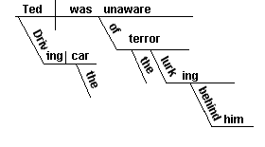
Infinitives are phrases beginning with the word "to" that act as nouns. Because they start with a word normally used as a preposition, they appear on a preposition-like "lazy L" sitting atop a forked stand which connects to the baseline where a noun would normally go.
Consider the following sentence:
Alex liked to swim fast.
"To swim fast" is an infinitive acting as the direct object answering "what" Alex likes. Since it is a direct object, it is acting like a noun. "Fast" is a modifier for "swim" so it will be diagrammed underneath in the modifier's normal position. The diagram for it looks like:
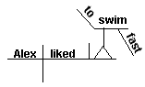
Appositives are words that rename another noun. Usually positioned next to the other noun, appositives really just help clarify or add details to the other noun they rename. Consider this sentence:
Our neighbor, Mr. Frazier, wrote a novel, My Fish.
Mr. Frazier is an appositive renaming neighbor.
My Fish is an appositive renaming the direct object, novel.
On the diagram, we simply place them beside the noun they rename and put parenthesis around the appositive.
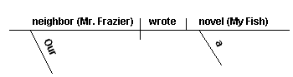
Clauses can be thought of as "mini" sentences within another sentence that act as adjectives, adverbs, or nouns. Clauses typically have their own subjects, verbs, and objects and accompanying modifiers. To diagram a sentence that contains a clause, first diagram the main sentence parts, then diagram the clause on a separate base line as if it were its own sentence, then connect the clause diagram to the main sentence diagram using a dashed line at the appropriate place - under the main sentence noun being modified by the clause if it is an adjective clause, or under the main sentence verb if it is an adverb clause, or above the main sentence baseline if it is a noun clause acting as a direct object, subject, or similar. Consider the following sentences:
He is the man who won the big race.
"who won the big race" is a clause acting as an adjective modifying "man". It has its own subject - "who", its own verb - "won", and its own direct object - "race". In the main sentence "He" is the subject, "is" is the verb, and "man" is a predicate noun. Diagrammed, this sentcnce looks like:
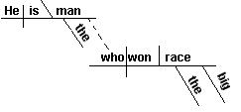
When the thunder rumbled, the baby cried loudly.
In this sentence, "When the thunder rumbled" is an adverb clause modifying the verb "cried" (telling when) in the main sentence "the baby cried loudly". Typically in a adverb clause you place the beginning adverb "when" of the clause on the dashed line connecting the two. Diagrammed, it would look like:
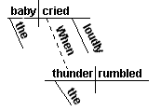
Many people say that he is a nice guy.
In this sentence, "that he is a nice guy" is a noun clause acting as the direct object - telling "what" many people say. It needs to go in the direct object position on the main baseline, so like other raised phrases and clauses we use the forked line to position it where it goes, then diagram it on its own baseline above. The relative pronoun "that" which is used to connect the clause to the main sentence is simply placed on a flat line above the clause's subject. Diagrammed, it looks like:
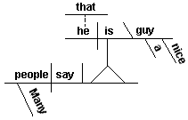
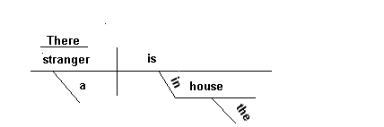
Nouns of Direct Address and expletives, such as 'hey' or 'there' are diagrammed
on unconnected lines above the main diagram,over the subject.
In this sentence: Hey! Mom, Dad, hand me those cookies!
The actual subject is an understood (you), with Hey being an expletive.
Mom and Dad are nouns of direct address.
The diagram looks like this:
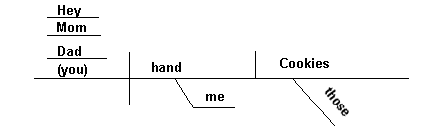
whereas this sentence: There is a stranger in the house. would look like this:

