Basic Sentence Parts and Patterns
- Simple subject and predicate
Samson slept.
- Understood subject (for commands, directives)
Sit!
- Questions
Where are you going?  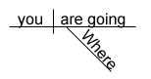 | What were you reading this morning?  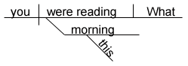
Whose bike were you using?  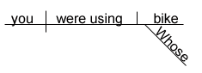 | May I postpone this assignment?

- Compound predicate
The cat howled and scratched ferociously.
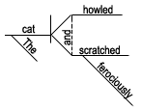
- Compound subject and compound predicate
Juanita and Celso worked hard and then rested.
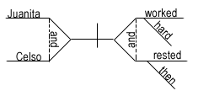
- Three subjects
Juanita, Federica, and Celso are working.
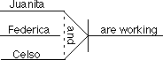
- Direct object
Tashonda sent e-mail.
- Compound direct objects
Tashonda sent cards and letters.
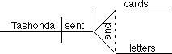
- Three direct objects
Tashonda sent e-mail, cards, and letters.
- Compound predicate with direct objects
Joselyn cooked breakfast and ate it.
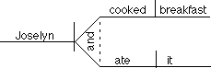
- Compound predicate with one direct object
Samantha proofreads and edits her essays.
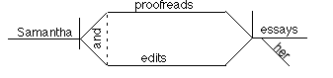
- Indirect object
Mrs. Doubtfire gave the children homework.
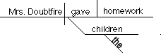
- Compound indirect objects
Mrs. Doubtfire gave Tabitha and Samantha quizzes.
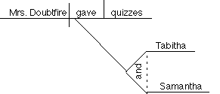
- Predicate noun
John Calhoun is a coach.
- Objective complement
Johnny painted his old jalopy purple.
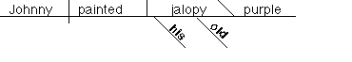
The club elected Tashonda [as its] president.
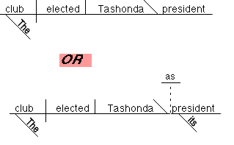
- Reflexive Pronouns
[as direct object] José cut himself.
[as indirect object] Mr. Edwards gave himself a raise.
[as object of a preposition] She cared only for herself.
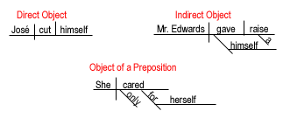
- Intensive Pronoun
I myself prefer basketball.
[or] I prefer basketball myself.
- Appositive
John Calhoun, the coach, yelled at the referees.
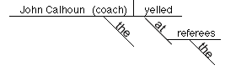
- Direct address
Heitor, address the class now.
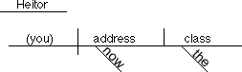
- Interjection
Man, that hurt!
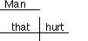
- Adjective
Athletic moves excite the crowd.
- Compound adjectives
The little old lady hit the tall and distinguished gentleman.
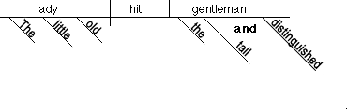
- Predicate adjective
Samson was powerful.
- Compound predicate adjectives
Samson was powerful but gullible.
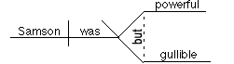
- Comparative adjective
Joanna is considerably taller than her brother [is].
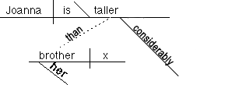
- Adverb
Dogsbreath works quickly.
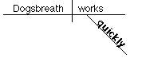
- Adverbs modifying other adverbs
A very friendly dog wags its tail quite often.
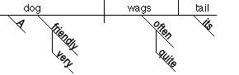
- Compound adverbs
Dr. Turveydrop waited patiently and quietly at the door.
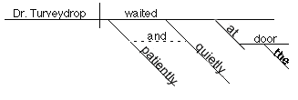
- Prepositional phrase
Charles is working in the garden.
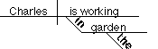
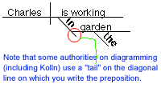
- Prepositional phrase modifying another prepositional phrase
Charles is working in the garden by the river.
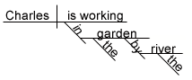
- Preposition with compound objects
The thought of getting up and working is alarming.
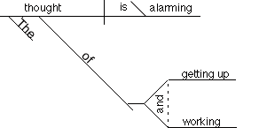
- Prepositional phrase modifying an adverb
Tashonda does her best work early during the semester.
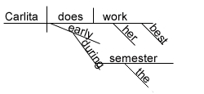
- Prepositional phrase as subjective complement
She felt under the weather.
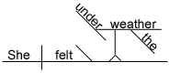
- Participle
The crumbling bridge must be repaired.
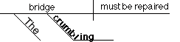
- Participial phrase
The screaming crowd watched the bridge falling into the river.
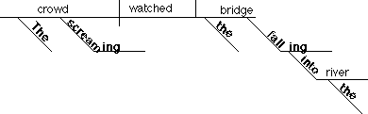
- Gerund
Working hard can be profitable.
- Gerund phrase acting as object
Terminata hates eating broccoli.
- Gerund phrase as object of a preposition
Wolfson wrote a book about playing basketball.
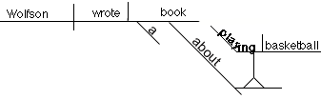
- Infinitive as noun (subject & predicate)
To know him is to love him.
- Infinitive acting as adjective
His decision to leave early was unfortunate.
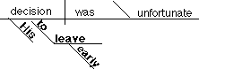
- Infinitive acting as adverb
He is determined to work hard.
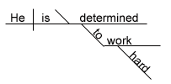
- Infinitive as direct object
The Eagles slowly began to climb the national rankings.
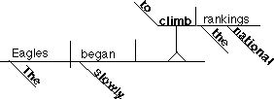
- Infinitive phrase as object of preposition
Pedrito had no choice except to run away.
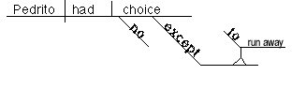
- Infinitive phrase as objective complement
Mom wanted me to do the dishes.
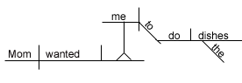
- Infinitive phrase as appositive
It was a mistake to elect William president.
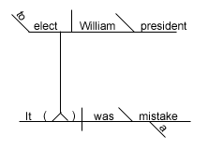
- Causative Verb
Professor Villa made her students read four novels.
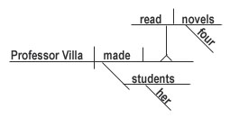
- Expletive Construction
There are never enough hot dogs at the annual picnic.
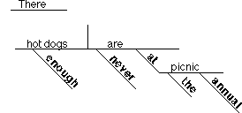
There is no one working with Albert.
- Absolute Construction
To tell the truth, I do not remember meeting her.
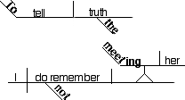
- Correlative Conjunction
Either we wash the walls, or we paint them.
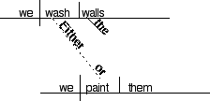
- Passive Verbs
The burglar was shot.
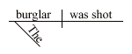
Mary was awarded the Smith Case.
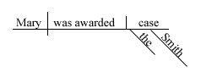
Turveydrop was named chairman while he was out of the room.
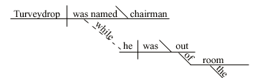

COMPOUND SENTENCE
Boggs hit the ball well, but he ran to the wrong base.
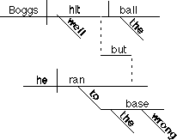
Another Example:
Forecasting technologies are more sophisticated and today's forecasters are better trained, but weather predictions are still not very reliable.
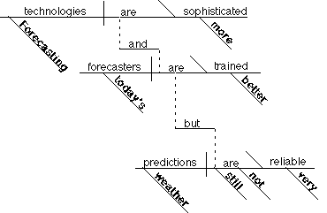
COMPLEX SENTENCES
1. Adjective clause introduced by an adverb
We slowly entered the theater where Lincoln was shot.
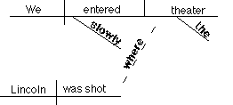
2. Adjective clause introduced by a relative pronoun acting as subject
That woman who just left the room will probably be the next president.
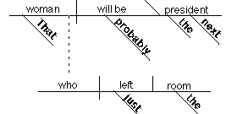
Another Example:
People who live in glass houses shouldn't throw stones.
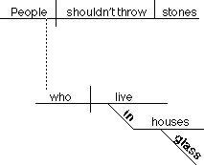
Yet Another Example:
I want to meet a man who I know will treat me right.
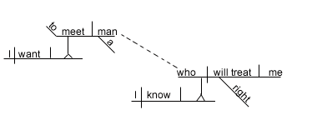
3. Adjective clause introduced by a relative pronoun as direct object.
The bill, which the house narrowly passed, was defeated by the senate.
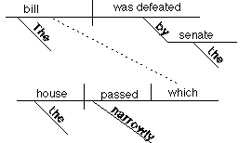
Another Example:
A man whom the grand jury indicted in December was arrested in Baltimore.
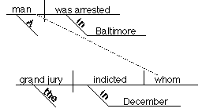
4. Adjective clause modifying a direct object
Charlene gave Dilbert all the trouble that he could handle.
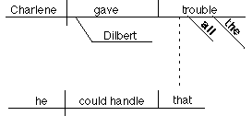
5. Adjective clause modifying the object of a preposition
Dogsbreath gave a million bucks to the nurse who saved his life.
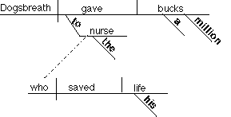
6. Adjective clause modifying the sentence subject
The car that Georgina bought was more expensive than mine.
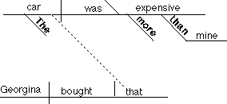
7. Adverb clause modifying the verb
We will go to the restaurant when this movie is finished.
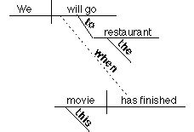
8. Adverb clause modifying an adjective
Playing billiards is more fun when you are good at it.
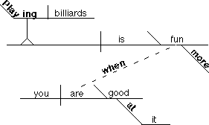
9. Adverb clause modifying an adverb
Josh walked quickly through the cemetery as if he were really frightened.
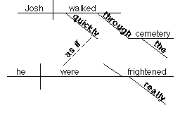
10. Noun clause acting as subject
What Ramon knew about cooking could fill a whole library.
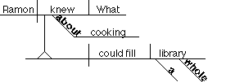
11. Noun clause acting as the object of a preposition
The couple had a huge argument about where they would live.
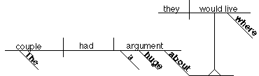
12. Noun clause acting as a predicate noun
What really matters is what you know.
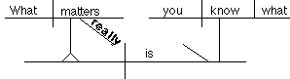
Another example:
Our biggest worry is that students won't read the signs.
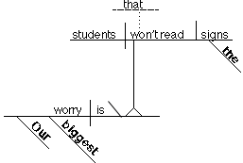
13. Noun clause acting as the object of the sentence
The New Yorker quickly rejected whatever Sarah submitted.
Another example:
We can only hope [that] it is not too late. (where the word "that" is omitted)
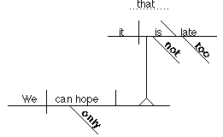
COMPOUND-COMPLEX SENTENCE
When the train goes through, the windows rattle noisily and the whole house shakes.
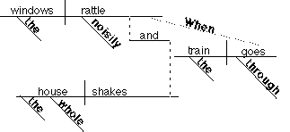

Guide to Grammar and Writing

